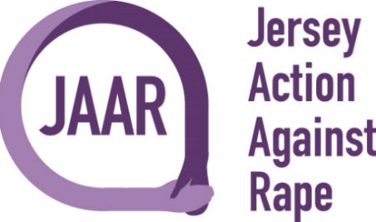

Polar Plunge Sponsorship Form
Sunday 20th December, Polar Plunge in aid of Jersey Action Against Rape and Beresford Street Kitchen.
The ultimate winter activity, Polar Plunge is guaranteed to heat up our Christmas fundraising efforts! Christmas fancy dress plunge into Victoria Marine Bathing Pool, West Park, St Helier.
Form Belongs to _________________________________________________
Donor Name | Amount Pledged per minute in the water | Flat Amount Pledged | Total Amount Due

