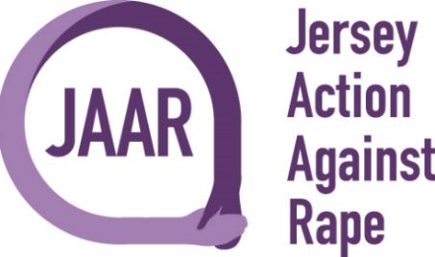

Polar Plunge Registration Form

Thank you for fundraising for JAAR and BSK
Full Name:

Address:

Contact Number:

Email Address:

Type of event: | Polar Plunge
Total fundraising amount hoping to raise for JAAR:

£10 Registration Fee for all Participants
Registration Fee payable to:
Jersey Action Against Rape
Bank A/C: 68296468
Sort Code: 30-94-61

Signature :

Date :

