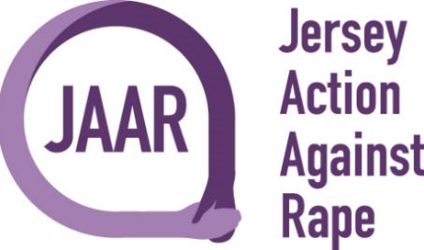

Sunflower Competition Registration Form
Thank you for fundraising for JAAR
Full Name:

Address:

Contact Number:

Email Address:

Type of event: | Sunflower Competition
Date:

£5 Registration Fee for all Participants
Registration Fee payable to:
Jersey Action Against Rape
Bank A/C: 68296468
Sort Code: 30-94-61
Bank Reference: Your Surname followed by SF

Please complete and return form to fundraising@jaar.je once we receive your completed form, we will send you some growing tips and a seed.

Thank you for taking part and supporting JAAR.

