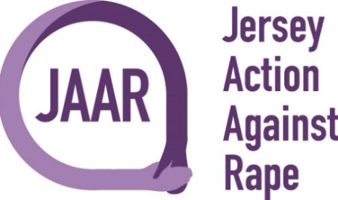

Wellness and Wildlife Walk Registration Form
Thank you for supporting for JAAR
Full Name:

Please list each person joining the walk.

Contact Number:

Email Address:

Type of event: | Wellness and Wildlife Walk
Date:

£25 Registration Fee for all Participants
Registration Fee payable to:
Jersey Action Against Rape
Bank A/C: 68296468
Sort Code: 30-94-61
Bank Reference: Your Surname followed by WWW
Please complete and return form to fundraising@jaar.je once we receive your completed form, we will send you confirmation of your entry.

Thank you for taking part and supporting JAAR.

