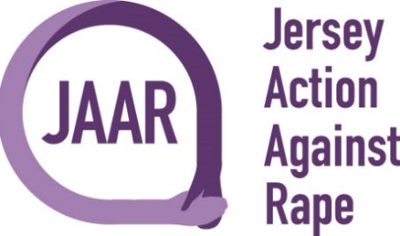

Halloween Plunge Event –11am on Sunday 31st October at the Victoria Bathing Pool

Full Name:

Please list each person joining the plunge.

Contact Number:

Email Address:

Type of event: | Halloween Plunge
Date: | 31st October (11am)

£10 Registration Fee for all Participants
Registration Fee payable to:
Jersey Action Against Rape
Bank A/C: 68296468
Sort Code: 30-94-61
Bank Reference: Your Surname followed by HP
Please complete and return form to fundraising@jaar.je

Thank you for taking part and supporting JAAR and BSK.

