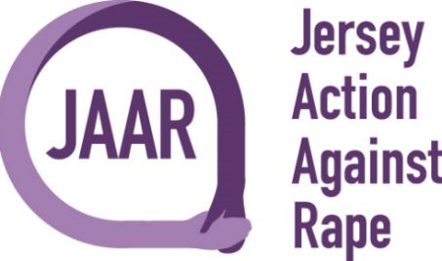

Stride For Survivors 2024 Charity Walk
Starting The Avenue Layby 1 to St Aubin and back.

Full Name:

Contact Number:

Email Address:

Type of event: | Stride For Survivors
Date: | Saturday 6th July 2024
In case of an emergency contact details: | Name:  Number:

Please complete and return form to admin@jaar.je

We extend our heartfelt gratitude for taking part of our "Stride for Survivors" Charity Walk. Your support means the world to us and makes a tangible difference in the lives of survivors of sexual assault trauma.
With your donations, we can continue providing essential trauma counselling services to those in need, empowering survivors on their journey towards healing and recovery. Your kindness and compassion inspire us every day to work tirelessly towards our mission of supporting survivors and creating a community of solidarity and support.
Once again, thank you for your generosity and for standing with us in our commitment to making a positive impact. Together, we can make a difference.

